15.JPG

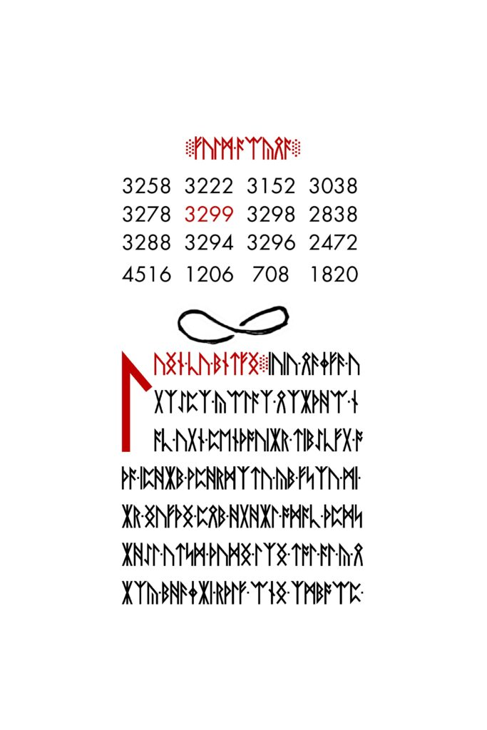

15.jpg

Runes ::: Delimiters ::: [Art](https://www.3301archive.com/15-jpg-art/)

~~~ [**Number** **Square**](https://www.3301archive.com/15-jpg-number-square/) ~~~

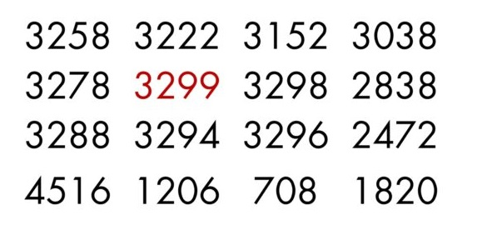15.jpg Number Square

***The 4×4***[***Number Square***](https://www.3301archive.com/15-jpg-number-square/)***featured on***[***15.jpg***](https://www.3301archive.com/15-jpg/)***is mathematically translatable in various ways. Listed below are the known interpretations:***

~~~~

**1.** [Prime Order Recurrence Relation](https://www.3301archive.com/15-jpg-number-square-recurrence-relation/)

**2.** [Fibonacci Base](https://www.3301archive.com/15-jpg-number-square-fibonacci-base/)

**3.**[Zeckendorf’s Theorem](https://www.3301archive.com/15-jpg-number-square-zeckendorf/)

~~~~

**Additional Reading**

*Mortlach*  
[Fibonacci Base Analysis](http://cicada3301.boards.net/thread/35/fibonacci-prime-spiral-zeckendorfs-theorem?page=1&scrollTo=56)  
[Zeckendorf Analysis](http://calypne.boards.net/thread/80/fibonacci-prime-spiral-zeckendorfs-theorem)

15.JPG ART

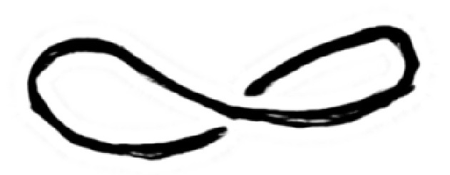15.jpg art

This symbol is found directly below the [Number Square](https://www.3301archive.com/15-jpg-number-square/) of [15.jpg](https://www.3301archive.com/15-jpg/). Its meaning is unknown.

**Common Interpretations**:  
  
Infinity  
  
Mobius

**Notes:**  
Adjusting the contrast reveals a secondary figure.

**\****The image(s) featured on this page are scaled. For unmodified 3301 images and materials, download the*[*Asset Pack*](https://www.3301archive.com/assets/)*.*